Step #1: Choose Object and Specify When to Start the Process
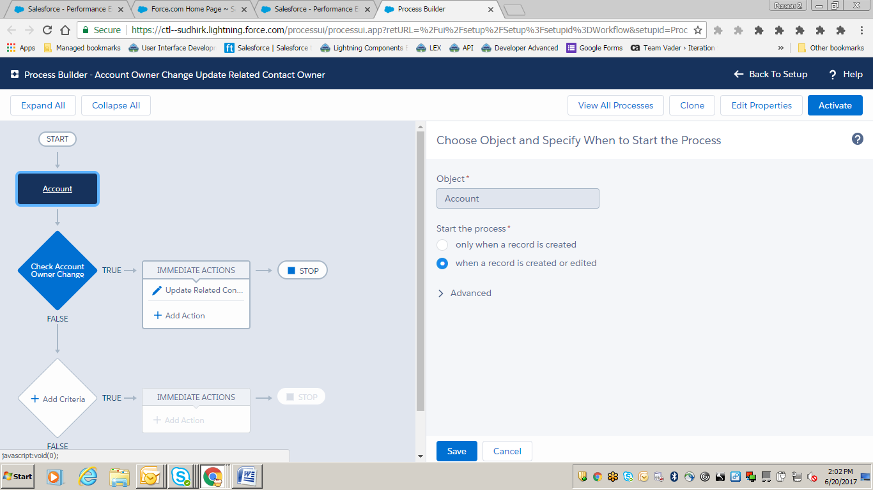
Step #2: Define Criteria for this Action Group
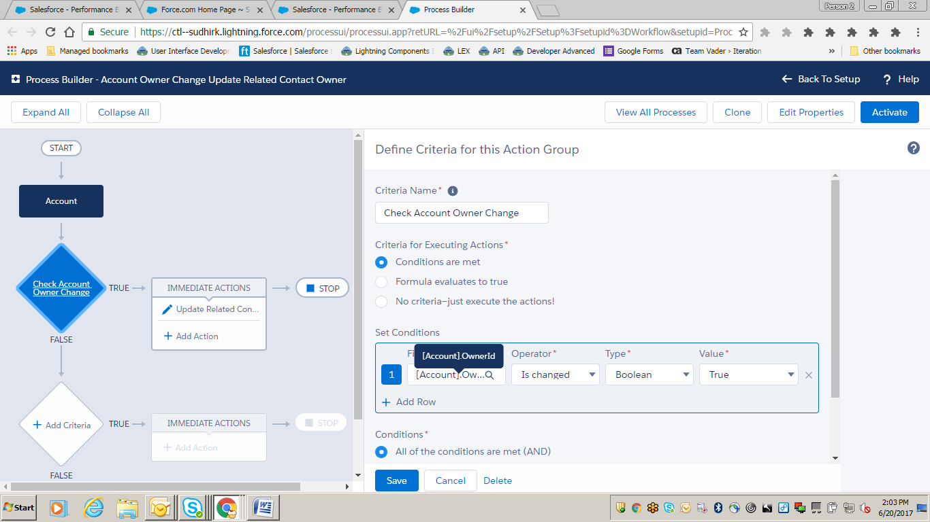

Step #3: Update Records
